Lab 8 Pseudocode & UML

10.5 (check palindrome)

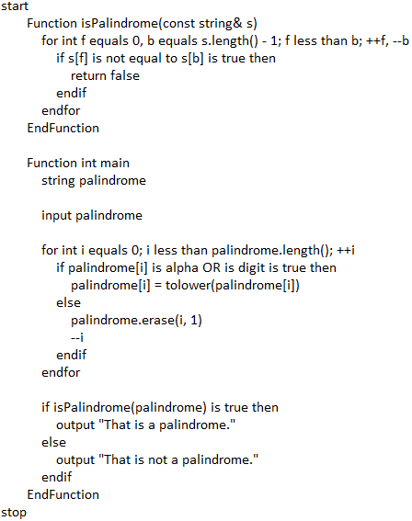

10.9 (location class)

